Korak 4 — Vue + Quasar SCADA Dashboard
Sada radimo frontend koristeći:
- Vue.js
- Quasar Framework
- Leaflet
- Vue-Leaflet
- Socket.IO Client
- Apache ECharts
Quasar je odličan za SCADA/IoT:
- dark industrial UI
- realtime dashboard layout
- responsive
- brze tablice i paneli
- odlične komponente

Što ćemo napraviti
Dashboard će imati:

Live mapa
- 1000 trafostanica
- realtime status
- alarm boje
- popup detalje

Alarm panel
- overheating
- overload
- kritične trafostanice

Live senzori
- napon
- struja
- temperatura
- harmonici

Grafovi
- load trend
- oil temp trend
- voltage trend

Struktura projekta
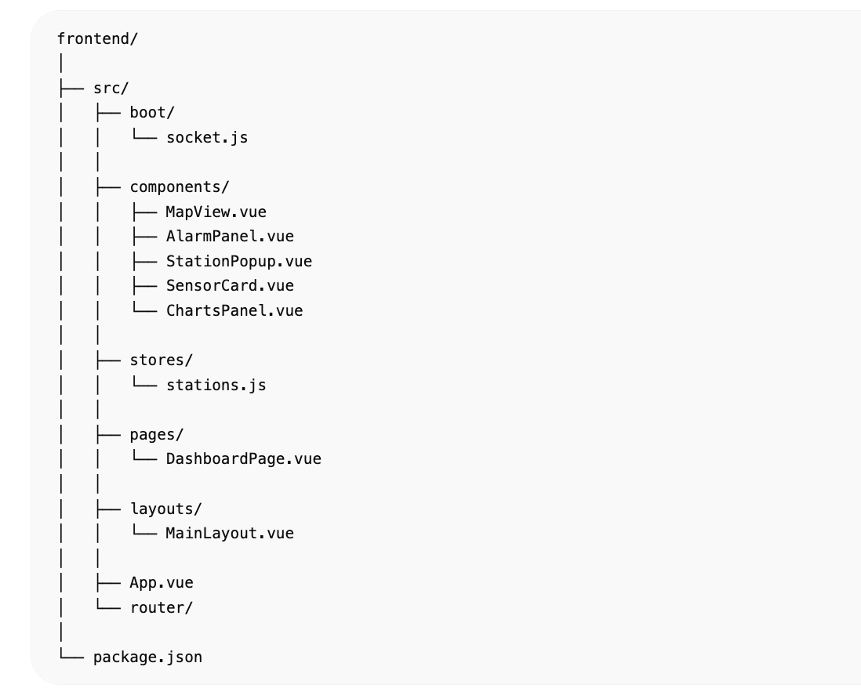

1. Kreiranje Quasar projekta
Instalacija:
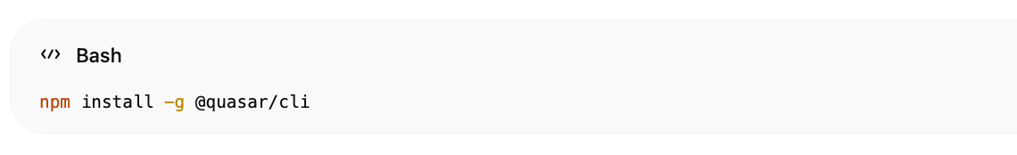npm install -g @quasar/cli

Kreiraj projekt
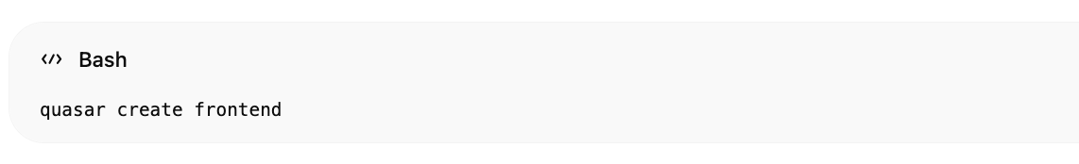
quasar create frontend
Odaberi:
- Vue 3
- Pinia
- ESLint

Pokreni
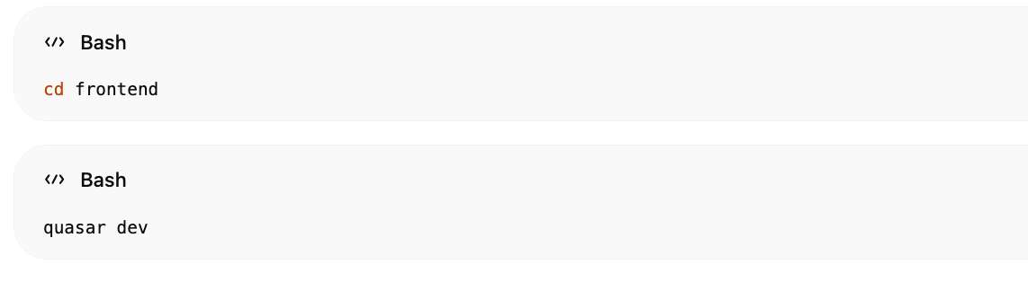
cd frontend
quasar dev

2. Instalacija paketa

Leaflet
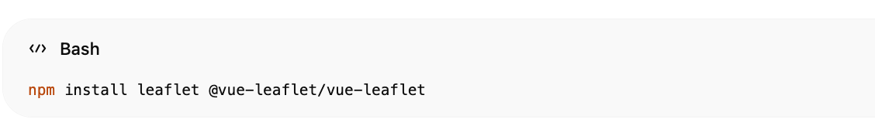npm install leaflet @vue-leaflet/vue-leaflet

Socket.IO
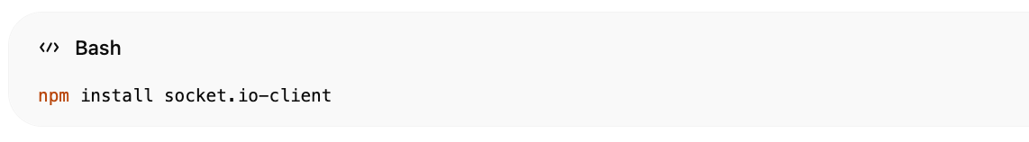npm install socket.io-client

ECharts
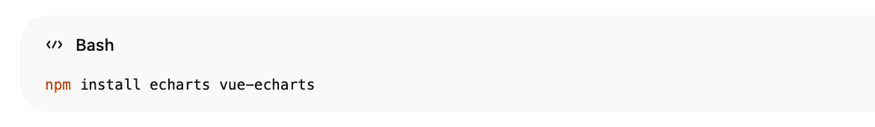npm install echarts vue-echarts

3. Socket boot file
src/boot/socket.js  import { boot } from 'quasar/wrappers'  import { io } from 'socket.io-client'  const socket = io(  'http://localhost:8000'  )  export default boot(({ app }) => {  app.config.globalProperties.$socket =  socket  })  export { socket } | 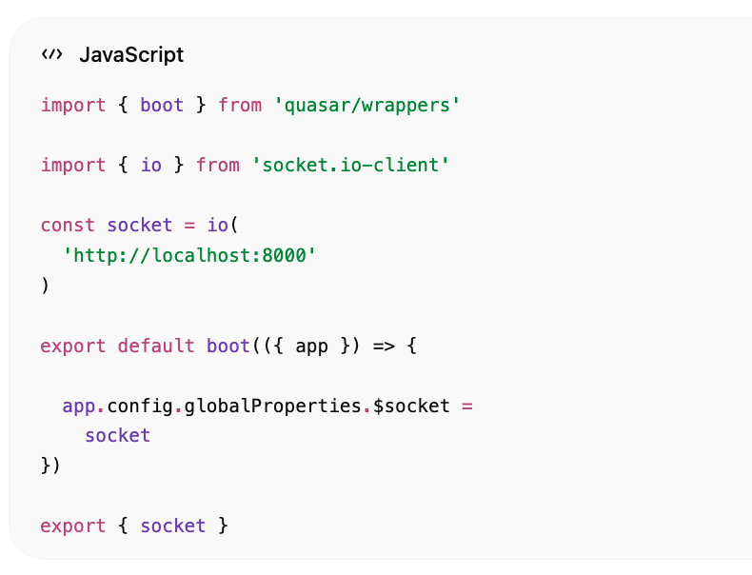

quasar.config.js
Dodaj boot:
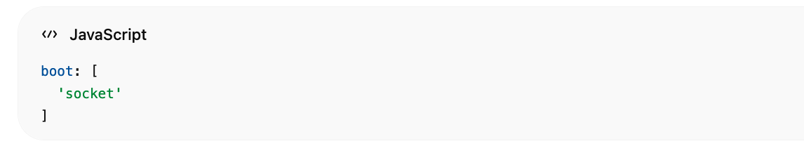boot: [
'socket'
]

Pinia Store
src/stores/stations.js
import { defineStore } from 'pinia'  export const useStationStore = defineStore(  'stations',  {  state: () => ({  stations: [],  alarms: []  }),  actions: {  updateStations(data) {  this.stations = data  this.alarms = data.filter(  s =>  s.alarms?.overheating ||  s.alarms?.overload  )  }  }  }  ) | 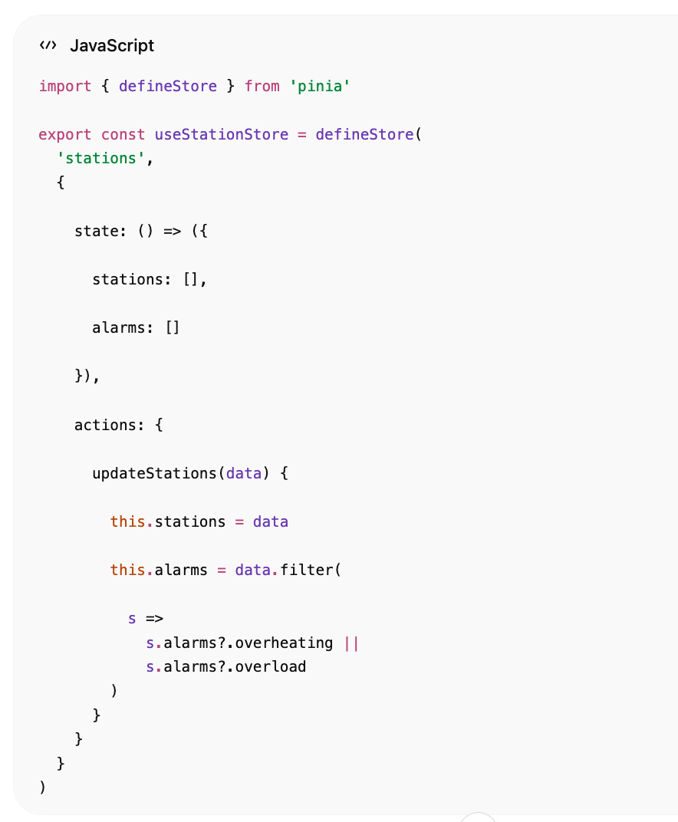

5. Leaflet mapa

src/components/MapView.vue
<template>  <l-map  :zoom="13"  :center="[46.3844, 16.4339]"  style="height: 100vh"  >  <l-tile-layer  url="https://{s}.tile.openstreetmap.org/{z}/{x}/{y}.png"  />  <l-marker  v-for="station in stations"  :key="station.station_id"  :lat-lng="[  station.location.coordinates[1],  station.location.coordinates[0]  ]"  >  <l-popup>  <StationPopup  :station="station"  />  </l-popup>  </l-marker>  </l-map>  </template>  <script setup>  import {  LMap,  LTileLayer,  LMarker,  LPopup  } from '@vue-leaflet/vue-leaflet'  import StationPopup from './StationPopup.vue'  defineProps({  stations: Array  })  </script> | 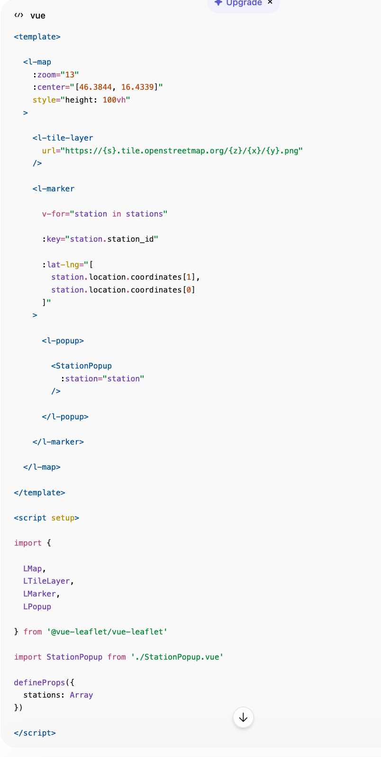

6. Popup trafostanice

StationPopup.vue
<template>  <div class="popup">  <div class="text-h6">  {{ station.station_name }}  </div>  <q-separator />  <div class="q-mt-sm">  <div>  Napon:  {{ station.electrical.voltage_kv }}  kV  </div>  <div>  Struja:  {{ station.electrical.current_a }}  A  </div>  <div>  Temp:  {{ station.thermal.oil_temp_c }}  °C  </div>  <div>  THD:  {{ station.electrical.harmonics_thd }}  %  </div>  </div>  </div>  </template>  <script setup>  defineProps({  station: Object  })  </script> | 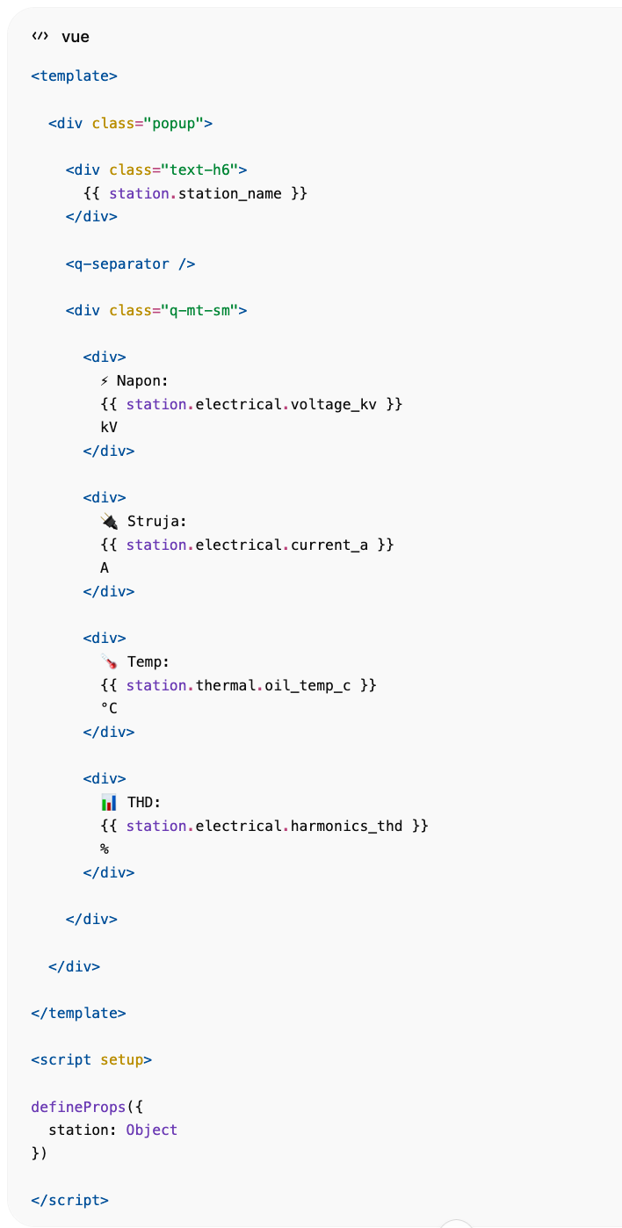

7. Alarm panel

AlarmPanel.vue
<template>  <q-card  dark  class="bg-red"  >  <q-card-section>  <div class="text-h6">  Aktivni Alarmi  </div>  </q-card-section>  <q-list bordered>  <q-item  v-for="alarm in alarms"  :key="alarm.station_id"  >  <q-item-section>  {{ alarm.station_name }}  </q-item-section>  </q-item>  </q-list>  </q-card>  </template>  <script setup>  defineProps({  alarms: Array  })  </script> | 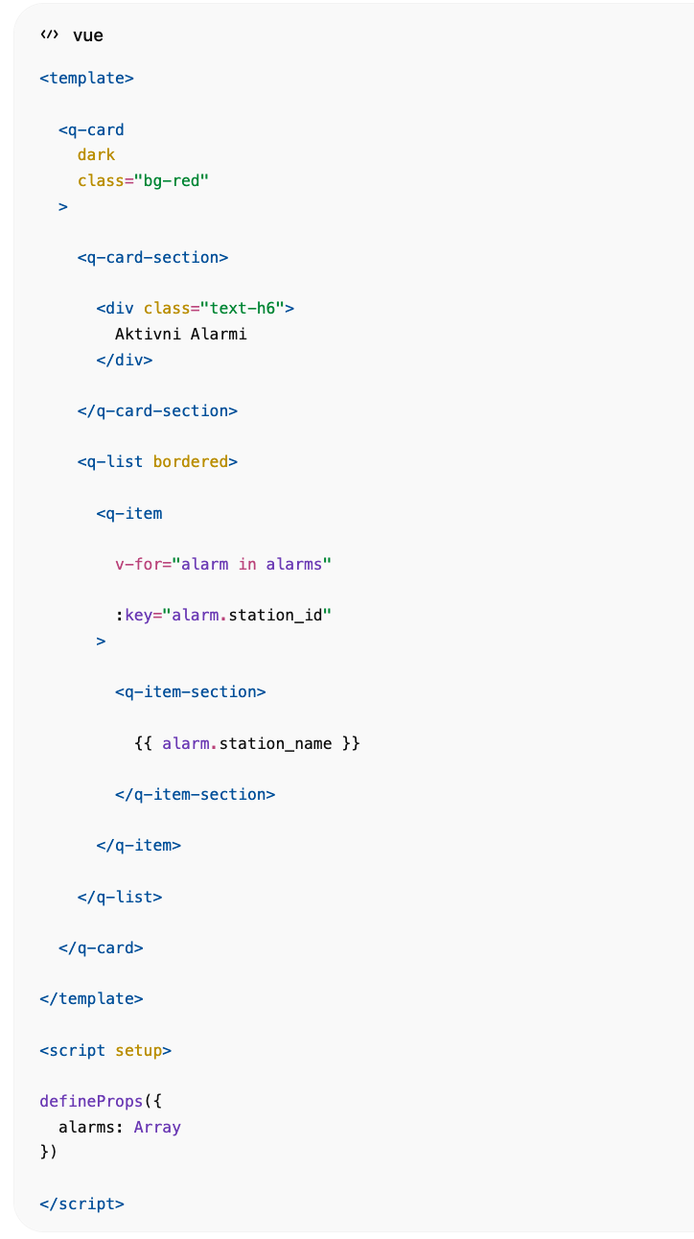

8. Dashboard page

DashboardPage.vue
<template>  <q-page class="bg-dark text-white">  <div class="row">  <div class="col-3 q-pa-sm">  <AlarmPanel  :alarms="store.alarms"  />  </div>  <div class="col-9">  <MapView  :stations="store.stations"  />  </div>  </div>  </q-page>  </template>  <script setup>  import { onMounted } from 'vue'  import { socket } from 'boot/socket'  import { useStationStore }  from 'stores/stations'  import AlarmPanel  from 'components/AlarmPanel.vue'  import MapView  from 'components/MapView.vue'  const store = useStationStore()  onMounted(() => {  socket.on(  'sensor_update',  (data) => {  store.updateStations(data)  }  )  })  </script> | 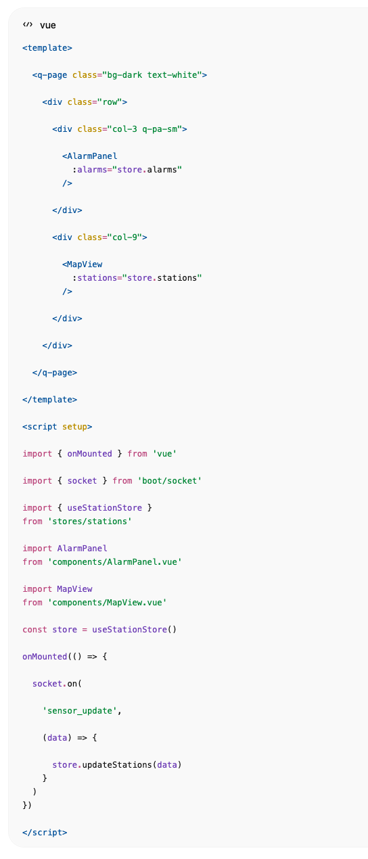

9. Dark SCADA tema

quasar.config.js
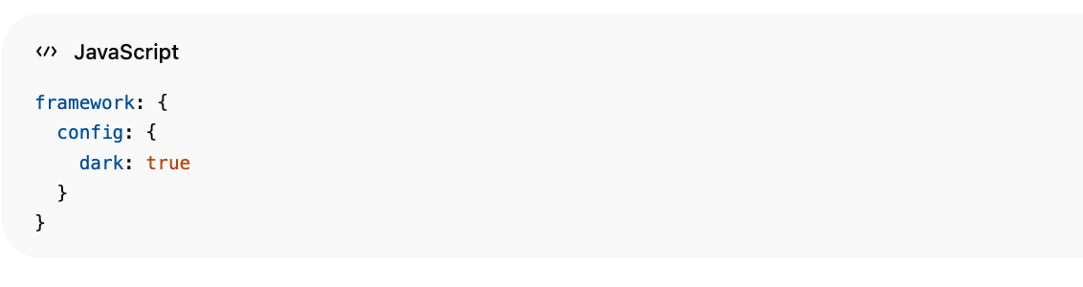framework: {
config: {
dark: true
}
}

10. Pokretanje

Dev mode
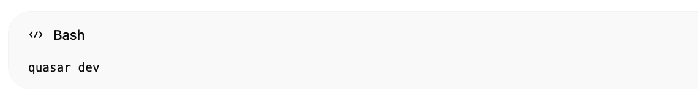quasar dev

Frontend
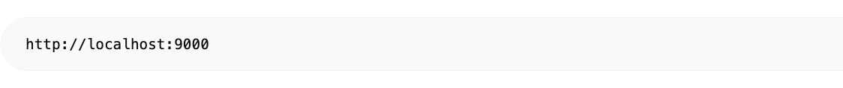http://localhost:9000

Što sada radi

Dashboard:
- realtime websocket
- 1000 trafostanica
- live Leaflet mapa
- alarm panel
- popup senzori
- dark SCADA UI

Sljedeći korak
Možemo dodati:

Live grafove
- voltage trend
- oil temp trend
- power usage

SCADA funkcije
- blinking alarmi
- status boje
- clusteriranje markera
- filtering
- search
- fullscreen monitoring

Napredne funkcije
- AI anomaly detection
- predictive maintenance
- Grafana integration
- mobile responsive
- Kubernetes deployment
- multi-city support
- HEP-style topology view
窗体顶端

窗体底端

